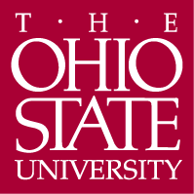

Department of Germanic Languages and Literatures

498 Hagerty Hall
1775 College Road
Columbus, OH 43210-1340

Phone (614) 292-6985
Fax (614) 292-8510

http://germanic.osu.edu

April 17, 2019

To: Meg Daly, Chair of ASCC
From: Carmen Taleghani-Nikazm, Chair of ASCC Arts and Humanities Panel 2

Ref: Approval of revisions to the Hebrew and Jewish Studies major, Hebrew minor, Jewish Studies minor, and Jewish Oral History minor

On Wednesday, April 3, 2019, the Arts and Humanities Panel 2 reviewed a proposal to revise Hebrew and Jewish Studies major, Hebrew minor, Jewish Studies minor, and Jewish Oral History minor in the Department of Near Eastern Languages and Cultures (NELC). The revisions were part of the larger ongoing changes that NELC has undertaken to its programs and were motivated by recent changes in NELC faculty, student enrollment, course offerings, and external reviewer’s feedback.

The changes to the programs include: a) combining Hebrew and Jewish Studies majors into a single major, with distinct language and interdisciplinary tracks, b) developing new learning objectives and assessment plans, c) revisions of required courses and elective lists, and d) modify course numbers and create new courses to ensure sufficient number of upper-division courses.

The panel agreed that the proposed revisions offer better options for students and faculty in the program. All the program revisions were unanimously approved by our panel and we now advance the major and minor proposals to the Arts and Sciences Curriculum Committee with a motion to approve.

Sincerely,

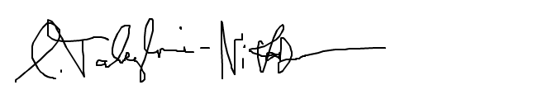

Carmen Taleghani-Nikazm

